Supplementary Material

Photocrosslinked PEG-PVP-Pullulan Composites Reinforced With Brushite: A Preliminary Bone-Facing Material for Osteochondral Tissue Engineering
Karina Niziołek^{1, 2,} *, Dagmara Słota², Katarzyna Haraźna², Agnieszka Sobczak-Kupiec²
¹ Cracow University of Technology, CUT Doctoral School, Faculty of Materials Engineering and Physics, Department of Materials Science, 31-864 Krakow, Poland
² Cracow University of Technology, Faculty of Materials Engineering and Physics, Department of Materials Science, 31-864 Krakow, Poland
*Correspondence: karina.niziolek@pk.edu.pl (Karina Niziołek)
Email: karina.niziolek@pk.edu.pl

- Selection of Formulation Parameters and Preliminary Screening
A series of polymer and polymer – ceramic composite formulations were designed to evaluate the effect of composition, crosslinking agents, and processing parameters on the final material properties (Table S1). The compositions were based on varying ratios of PEG and PVP, with the addition of pullulan and the use of PEGDA (575 or 700) as a crosslinking agent. In selected formulations, DCPD was introduced as an additional component to obtain composite systems. All materials were prepared using the same procedure as described in the main manuscript.
Preliminary screening allowed identification of formulations suitable for further investigation. Among all tested systems, samples 2.1, 3.1, and 4.1, as well as their corresponding DCPD-containing counterparts (2.2, 3.2, and 4.2), were selected for the main part of the study due to their appropriate physicochemical properties and structural integrity. For clarity, these samples were further denoted as A, B, and C, and A-DCPD, B-DCPD, and C-DCPD, respectively.
Formulations based on PEGDA 575 were excluded from further analysis, as they did not meet the required criteria. In several cases, these materials were not fully crosslinked within the assumed curing time of 4 min, or they exhibited unfavorable properties such as excessive stiffness, brittleness (cracking), or surface irregularities (waviness).
To provide a more comprehensive understanding of these systems, additional analyses were performed for the rejected formulations, including FT-IR spectroscopy, pH measurements, conductivity studies, and swelling behavior, and are presented in the following sections of the Supplementary Materials.
Table S1. Designing the composition and developing formulations for polymer-ceramic composites.
Sample | PEG [mL] | PVP [mL] | Pullulan [g] | DCPD [g] | PEGDA 575  [mL] | PEGDA 700  [mL] | Photoinitiator [µL]
1.1 | 10 | - | 0.5 | - | - | 2 | 50
2.1 → A | 7.5 | 2.5
3.1 → B | 5 | 5
4.1 → C | 2.5 | 7.5
5.1 | - | 10
6.1 | 10 | - | 0.5 | - | 2 | - | 50
7.1 | 7.5 | 2.5
8.1 | 5 | 5
9.1 | 2.5 | 7.5
10.1 | - | 10
1.2 | 10 | - | 0.5 | 0.5 | - | 2 | 50
2.2 → A-DCPD | 7.5 | 2.5
3.2 → B-DCPD | 5 | 5
4.2 → C-DCPD | 2.5 | 7.5
5.2 | - | 10
6.2 | 10 | - | 0.5 | 0.5 | 2 | - | 50
7.2 | 7.5 | 2.5
8.2 | 5 | 5
9.2 | 2.5 | 7.5
10.2 | - | 10

- FT-IR Analysis of the Obtained Materials
The FT-IR spectra of polymer matrices (Fig. S1A) and polymer–ceramic composites (Fig. S1B) show characteristic bands corresponding to the main components of the system, including O–H (~3200–3500 cm⁻¹), C–H (~2900 cm⁻¹), C=O (~1650 cm⁻¹), and C–O–C/C–O (~1100–1000 cm⁻¹) vibrations.
No significant differences in the overall spectral profiles between the samples are observed, suggesting that the general chemical structure remains similar across the series. A decrease in the intensity of bands associated with C=C vibrations (originating from PEGDA) may indicate partial consumption of double bonds during the crosslinking process. For the composites, slight changes in band intensity can be noted, which may be attributed to interactions between the polymer matrix and the inorganic phase; however, no new distinct peaks are observed.
Fig. S1. FT-IR spectra of materials and composites. (A) The obtained polymer materials. (B) The obtained polymer–ceramic composites.

- pH Changes During Incubation in Different Media
The pH values of all samples remained within a relatively narrow range during the entire incubation period, indicating overall chemical stability of the investigated systems (Fig. S2). For polymer matrices, only slight fluctuations in pH were observed regardless of the medium, suggesting limited interaction with the surrounding environment and negligible release of species affecting the acidity/alkalinity. In contrast, the corresponding composites exhibited somewhat more pronounced variations, particularly in simulated body fluid (SBF) and distilled water, where gradual increases or decreases in pH were noted over time. These changes may be attributed to enhanced interactions between the composite components and the medium, as well as partial release or exchange of ionic species. Nevertheless, the magnitude of these variations remained moderate, confirming that both matrices and composites maintain stable pH conditions during incubation.
Fig. S2. Changes in pH as a function of incubation time for polymer matrices (left column) and their corresponding composites (right column) in different media: Ringer’s solution (A, B), artificial saliva (C, D), simulated body fluid (SBF) (E, F), and distilled water (G, H).

- Electrical Conductivity Changes During Incubation in Different Media
The electrical conductivity of the tested systems showed time-dependent changes that varied with both the material type and the incubation medium (Fig. S3). Polymer matrices displayed relatively stable conductivity values with only minor fluctuations, indicating limited ion release and low interaction with the surrounding solutions. In contrast, the composites exhibited more noticeable variations in conductivity, particularly in SBF and artificial saliva, where an overall increase or more dynamic changes were observed during incubation. This behavior suggests a higher degree of ionic mobility and possible ion exchange processes occurring in the presence of the additional composite phase. In distilled water, changes in conductivity were also evident, reflecting the gradual leaching of ionic species from the materials. Overall, the results indicate that the incorporation of the secondary phase in the composites enhances their interaction with the medium, influencing ion transport and release phenomena.
Fig. S3. Changes in electrical conductivity as a function of incubation time for polymer matrices (left column) and their corresponding composites (right column) in the same media: Ringer’s solution (A, B), artificial saliva (C, D), simulated body fluid (SBF) (E, F), and distilled water (G, H).

- Swelling Kinetics of Polymer Matrices and Composites
An analysis of swelling parameters in distilled water demonstrated that the composition of materials affects their ability to absorb liquids (Fig. S4). A significant factor influencing the properties of the hydrogels was the molecular weight of the PEGDA crosslinking agent used. The use of PEGDA with a higher molecular weight (Mn = 700) results in materials characterised by a larger free volume, which promotes increased swelling. These differences result from the length of the PEGDA chains, which determines the distance between cross-linking points and the mobility of the polymer chains. Furthermore, the presence of a mineral phase in the form of DCPD reduced the swelling capacity, which can be explained by the filler effect limiting the freedom of the network and reducing the available spaces for water absorption. Additionally, the presence of hydroxyl groups in DCPD may promote the formation of additional crosslinking points, which can also restrict the freedom of the chains. The kinetic parameter τ indicates varying rates at which the developed materials reach equilibrium (Table S2). The observed differences may result from changes in the structure of the materials and the mobility of the polymer chains, which influence the rate of fluid diffusion into the network.
Fig. S4. Swelling behavior of polymer matrices (left column) and their corresponding composites (right column) as a function of incubation time. Panels (A–D) represent different sample series with varying compositions.

Table S2. Rate parameter (τ) and equilibrium swelling (S_{e}) of polymer matrices and composites.
Sample | S_{e} (%) | τ
1.1 | 216.71 ± 5.04 | 34.49 ± 4.72
5.1 | 189.62 ± 2.49 | 13.73 ± 2.01
6.1 | 196.83 ± 4.19 | 34.06 ± 4.31
7.1 | 176.42 ± 4.21 | 14.77 ± 3.56
8.1 | 215.71 ± 7.95 | 39.62 ± 8.47
9.1 | 186.94 ± 4.02 | 34.69 ± 4.50
10.1 | 176.76 ± 5.99 | 35.13 ± 7.01
1.2 | 186.82 ± 6.22 | 15.71 ± 4.97
5.2 | 169.27 ± 3.81 | 9.16 ± 4.92
6.2 | 178.50 ± 4.32 | 14.31 ± 3.66
7.2 | 168.48 ± 2.45 | 12.67 ± 2.29
8.2 | 178.03 ± 2.04 | 22.22 ± 1.81
9.2 | 176.39 ± 3.12 | 29.48 ± 3.23
10.2 | 141.18 ± 3.17 | 11.99 ± 3.64

- FT-IR Analysis after Incubation
Fig. S5. FT-IR spectra of polymer–ceramic composites after incubation in different media. (A) Sample A-DCPD. (B) Sample B-DCPD. (C) Sample C-DCPD.

- Optical Images, 3D Surface Topography, and Roughness Profiles after Incubation
Fig. S6. Representative optical images, 3D surface reconstructions, and corresponding roughness profiles of the investigated polymer and polymer–ceramic samples after incubation in SBF. The red line indicates the profile line used for roughness analysis.
Fig. S7. Representative optical images, 3D surface reconstructions, and corresponding roughness profiles of the investigated polymer and polymer–ceramic samples after incubation in PBS. The red line indicates the profile line used for roughness analysis.
Fig. S8. Representative optical images, 3D surface reconstructions, and corresponding roughness profiles of the investigated polymer and polymer–ceramic samples after incubation in Ringer’s solution. The red line indicates the profile line used for roughness analysis.

Fig. S9. Representative optical images, 3D surface reconstructions, and corresponding roughness profiles of the investigated polymer and polymer–ceramic samples after incubation in artificial saliva. The red line indicates the profile line used for roughness analysis.

- SEM/EDS Analysis After Direct Cytotoxicity Evaluation
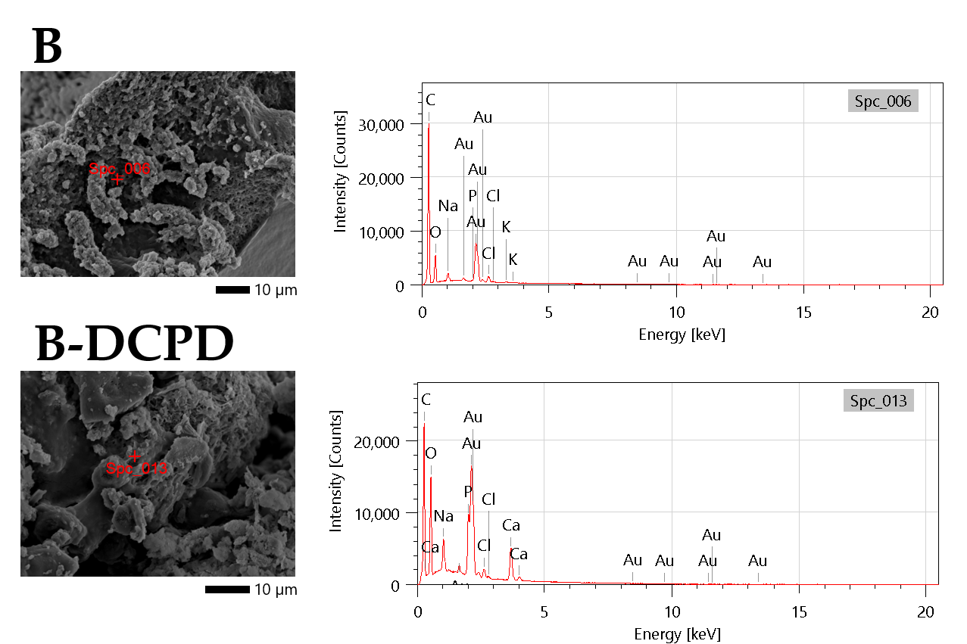
Fig. S10. Representative SEM images and corresponding EDS spectra of B and B-DCPD composites following direct cytotoxicity testing. Red markers indicate the regions selected for elemental analysis.

Table S3. Elemental composition of cell-covered regions on the surfaces of B and B-DCPD composites after direct cytotoxicity evaluation, determined by EDS analysis. Results are expressed as mass percentage (Mass %) and atomic percentage (Atom %).
Element | Sample B |  | Sample B-DCPD
Element | %M. | %At. | %M. | %At.
C | 53.86 ± 0.11 | 83.32 ± 0.17 | 27.69 ± 0.07 | 57.81 ± 0.14
O | 9.76 ± 0.08 | 11.33 ± 0.10 | 14.81 ± 0.08 | 23.21 ± 0.12
Na | 1.05 ± 0.02 | 0.85 ± 0.02 | 2.04 ± 0.02 | 2.22 ± 0.03
P | 0.22 ± 0.02 | 0.13 ± 0.01 | 5.98 ± 0.05 | 4.84 ± 0.04
Cl | 2.02 ± 0.04 | 1.06 ± 0.02 | 1.38 ± 0.03 | 0.97 ± 0.02
K | 0.51 ± 0.03 | 0.24 ± 0.01 | – | –
Ca | – | – | 9.68 ± 0.09 | 6.06 ± 0.06
Au | 32.59 ± 0.22 | 3.07 ± 0.02 | 38.43 ± 0.19 | 4.89 ± 0.02

- SEM/EDS Analysis After Direct Proliferation Test
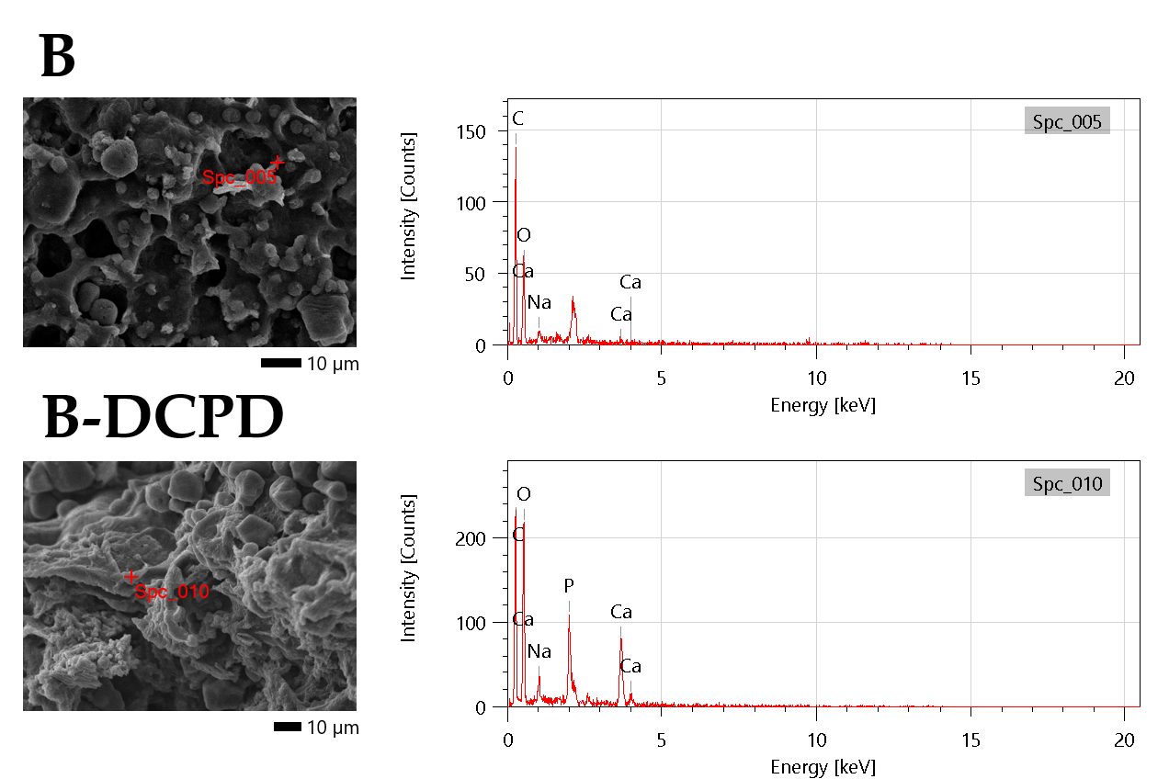
Fig. S11. Representative SEM images and corresponding EDS spectra of B and B-DCPD composites following direct proliferation testing. Red markers indicate the regions selected for elemental analysis.

Table S4. Elemental composition of cell-covered regions on the surfaces of B and B-DCPD composites after direct proliferation test, determined by EDS analysis. Results are expressed as mass percentage (Mass %) and atomic percentage (Atom %).
Element | Sample B |  | Sample B-DCPD
Element | %M. | %At. | %M. | %At.
C | 56.10 ± 1.69 | 63.55 ± 1.92 | 39.93 ± 0.92 | 51.11 ± 1.18
O | 41.30 ± 3.32 | 35.13 ± 2.82 | 42.77 ± 1.80 | 41.11 ± 1.73
Na | 1.73 ± 0.50 | 1.03 ± 0.30 | 1.86 ± 0.27 | 1.24 ± 0.18
P | – | – | 5.45 ± 0.39 | 2.81 ± 0.20
Ca | 0.87 ± 0.42 | 0.29 ± 0.14 | 9.99 ± 0.68 | 3.73 ± 0.26

